Microsoft logo

Robotic Process Automation in a Day

Lab 6 – Add AI model to process invoice forms

30 mins

April 2023

Applies to Power Automate Desktop v. 2.31.105.23101 ([more](https://learn.microsoft.com/en-us/power-platform/released-versions/power-automate-desktop))



This document is provided “as-is.” Information and views expressed in this document, including URL and other Internet Web site references, may change without notice. You bear the risk of  
using it. Some examples are fictitious and are for illustration only. No real association is intended  
or inferred. This document does not provide you with any legal rights to any intellectual property in any Microsoft product. You may copy and use this document for your internal reference purposes.

© 2021 Microsoft Corporation. All rights reserved.

## Lab Overview

You will complete the following tasks in this lab:

* Build a new AI model for Form Processing
* Train the new AI model to process Contoso Invoice forms
* Integrate the new AI model into the Cloud flow from Lab 6
* Perform a test run of the updated Cloud flow and associated AI Builder-based predictions

## Prerequisites

This lab builds on the initial setup lab (lab 1), and labs 2-5 – ensure these labs are complete.

# Build and use AI models to enhance user experience in workflows

1. Open the test profile in a browser and navigate to <https://make.powerautomate.com/>
2. In the left navigation pane, select AI Builder.

1. Select Explore.

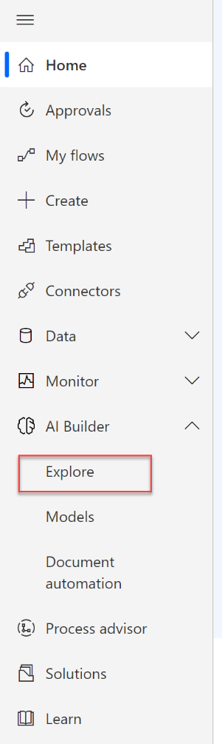

1. **Note:** You may see a prompt informing you that you need to get AI Builder. You can opt-in for a free, 30 days trial. The trial will also start automatically once you follow the steps below. Click **Start trail** button.

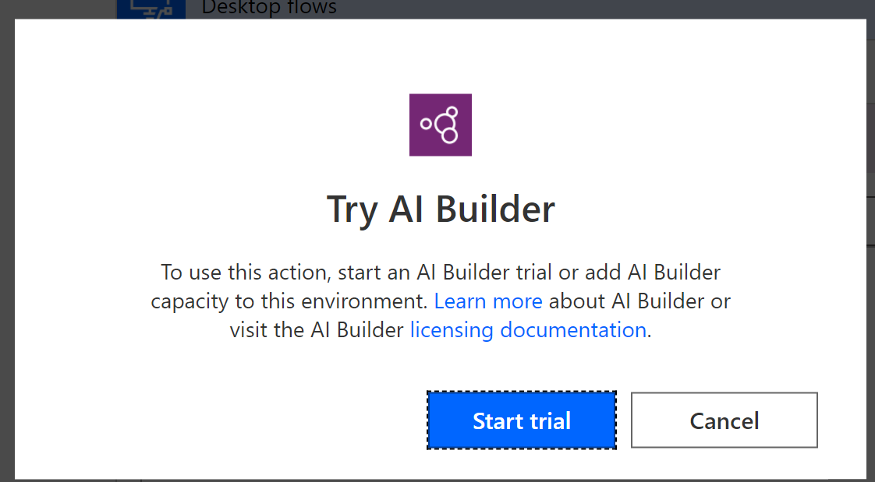

1. Filter to show only models for “Documents” and select Extract custom information from documents.

**Note:** You can as well use the pre-built “Extract information from invoices” model, that is suitable for most of the invoices’ layouts. For this lab however, we would like to show you how   
a custom model can be built.

1. Click **Get started**

1. Click on its pre-created name and rename it to Enter invoice information AI model. Next select the Structured and semi-structured documents type and click Next.

1. We will now create 4 fields for our AI Model. Click the dropdown arrow next to the **+ Add** button and select **Field** option.

1. Create the following field **Bill to** by entering its name in the **Name** text box and then click **Done**.

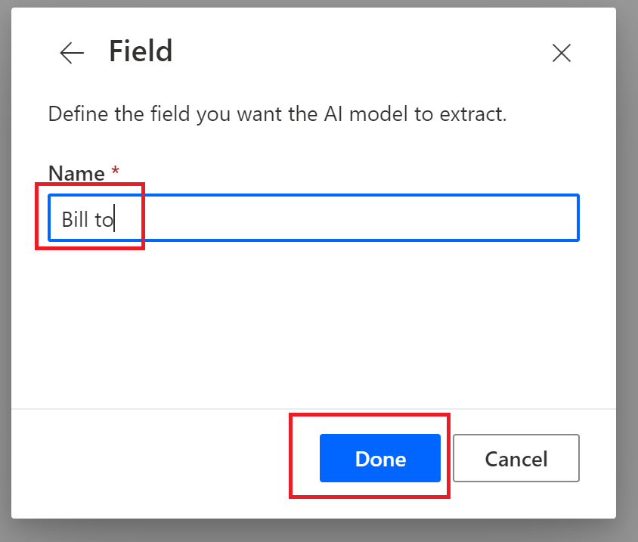

1. Repeat the steps above, until the 4 fields that we need to create include:
   1. Bill to
   2. Contact
   3. Date
   4. Total
2. Click **Next** button.

1. Collections allow for the grouping of documents for a particular organizer, customer, or counterparty. We will now create a collection for Contoso by clicking on Newcollection.

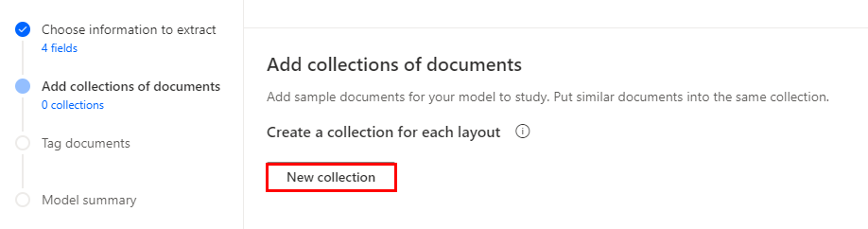

1. Double click on Collection1and then rename it to be called Contoso.

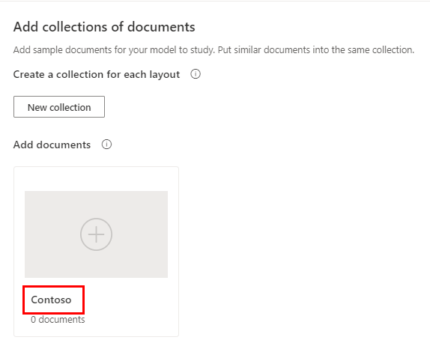

1. Click on the **+** sign to upload our sample PDF files from the lab resources folder. We will choose to Upload from local storage. The documents we want to upload include: (You can find them under the **Student lab data packages** folder.

* Contoso_INVOICE_(Fabrikam_UK).pdf
* Contoso_INVOICE_(Litware_CAN).pdf
* Contoso_INVOICE_(Proseware_NY).pdf
* Contoso_INVOICE_(TailSpin).pdf
* Contoso_INVOICE_(WingTip).pdf

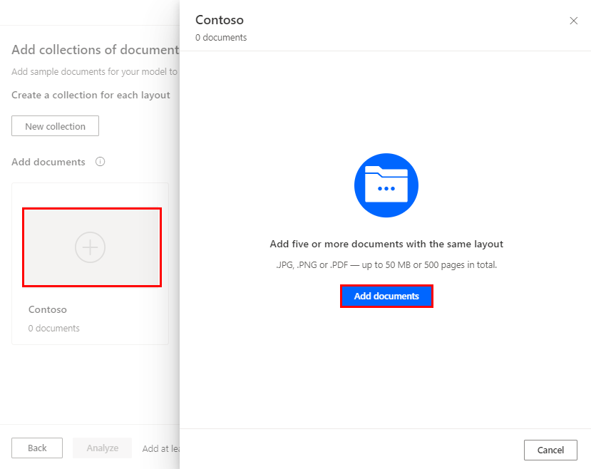

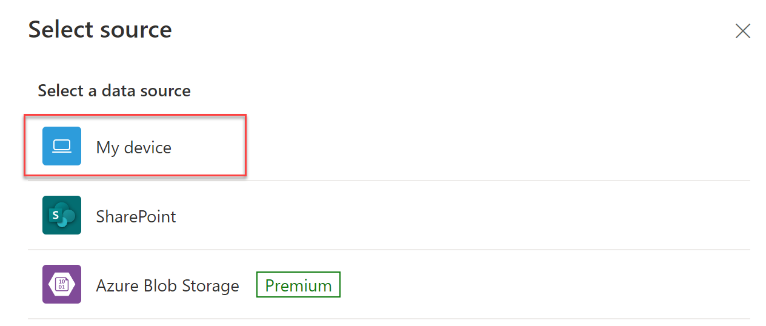

1. Select the 5 pdf files used for training and click **Upload 5 documents** button.

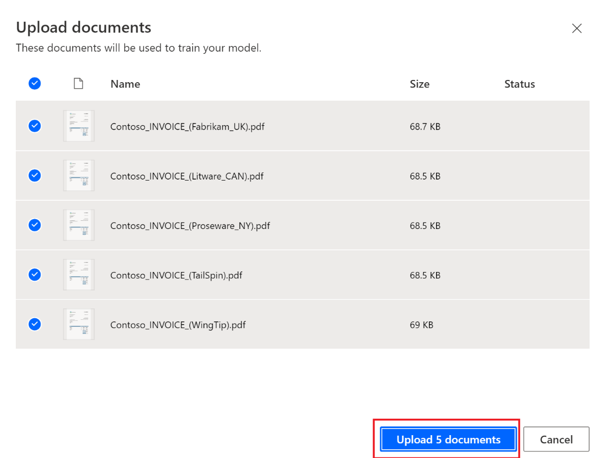

1. Once the documents have been uploaded, we should see a success message like the following image. Click Close to continue.

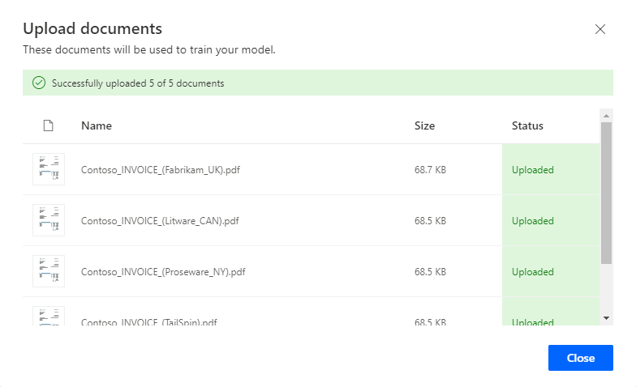

1. Click Next button.

1. We now need to tag our document. For each of our fields we need to hover over the respective area and then click on that area. When we do so, a menu will appear that allows us to assign that area to a specific field. As we do this, our Fields list will get checked off. Repeat this step to tag separately for each of the fields: Billto, Contact, Dateand Total**.**
2. Finished tag all the filed in document 1.

1. Now select the 2nd document. We need to ensure that our fields have been recognized on all our documents by clicking them one by one and examinate that we have green checkmarks beside our fields.

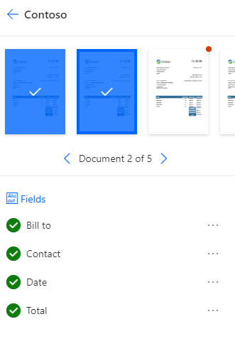

1. After we have validated all 5 documents, we can click on the Next button to continue.

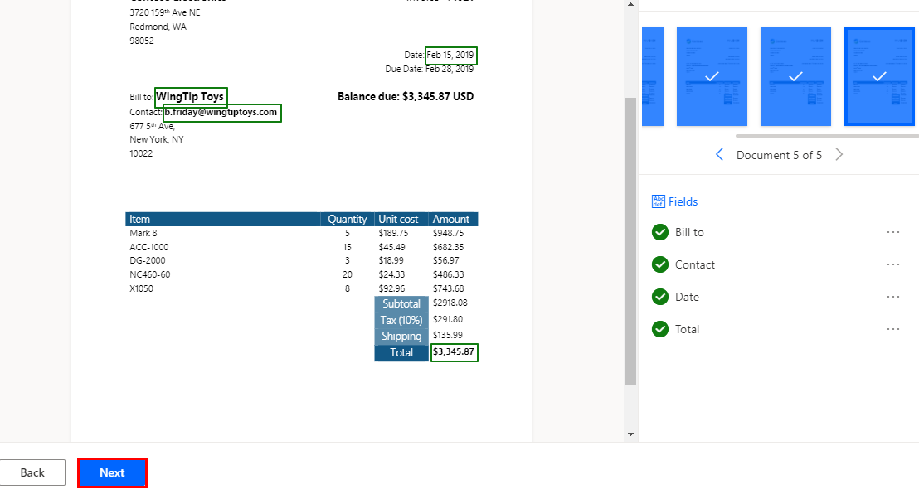

1. We are now ready to train our AI Model and can do so by clicking the **Train** button.

**Note:** This will take a couple minutes to complete.

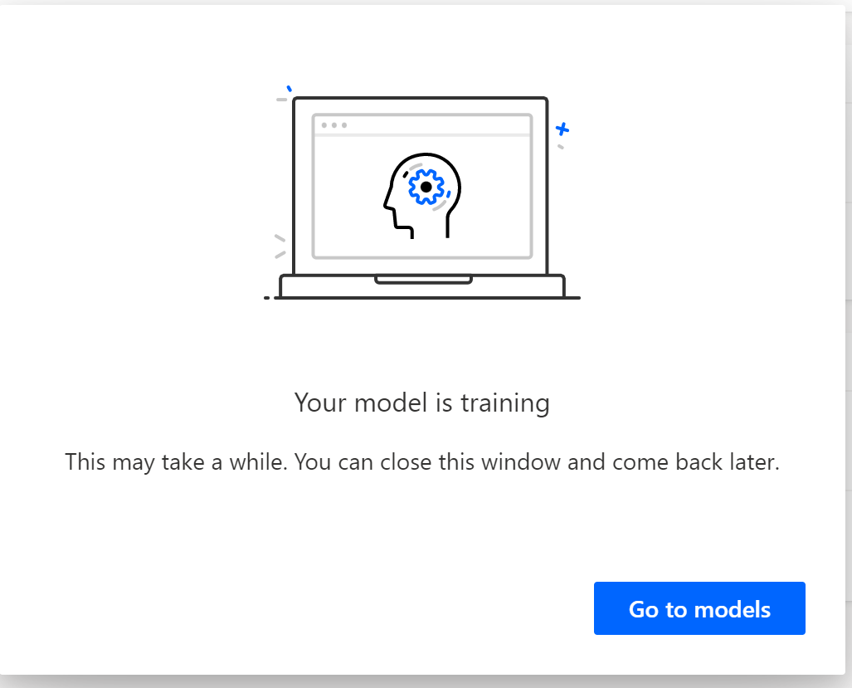

1. After AI Model training is completed, you can publish your AI model by clicking Publish.

**Note:** Publish your model when you want to make it available to users in your Power Automate environment.

1. You can find your AI models under AI builder > Models.

1. Now you have an AI model trained and published. Next, you will learn how to use this AI model that you just trained in your automation. From the left navigation menu, go to Solutions and open Invoice processing solution.

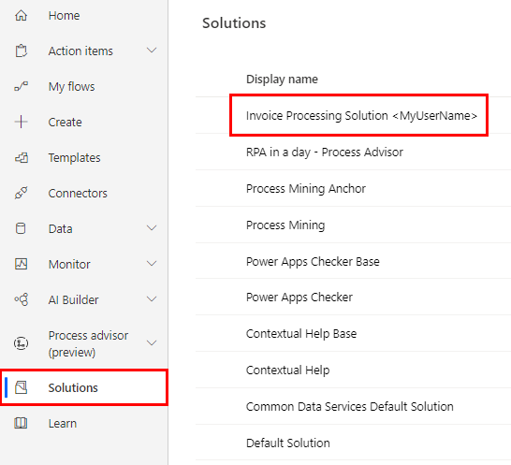

1. You need to add the AI Model to the solution. To do that, click **Add existing** 🡪 **AI Model**.

1. Select the **Enter invoice information** AI model and click **Add** button.

1. Open Use Outlook email to trigger Desktop flow cloud flow.

1. Click Edit

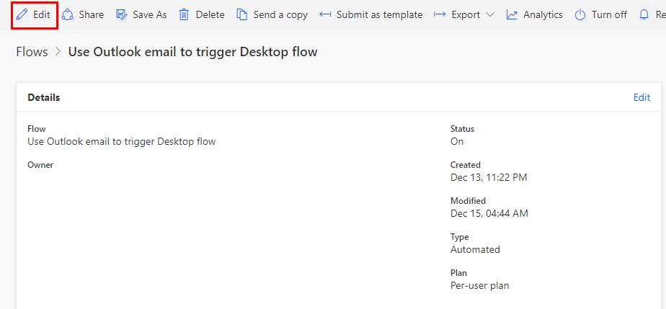

1. Delete Run a flow built with Power Automate Desktop step by clicking … > Delete

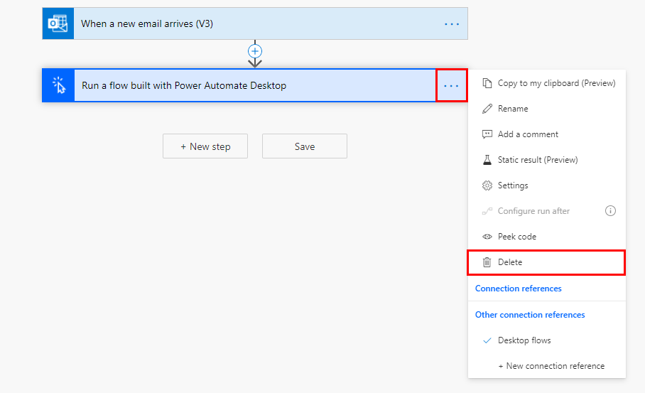

1. Add a new step.

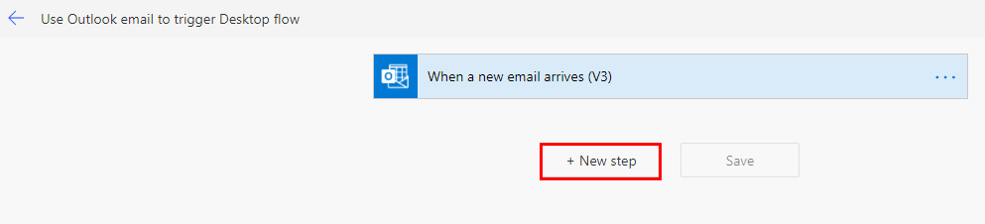

1. Select AI Builder.

1. Search for Extract using the search bar. Select Extract information from documents.

**Note:** You can as well use the pre-built “Extract information from invoices” model, that is suitable for most of the invoices’ layouts. For this lab however, we would like to show you how to use a custom model.

1. Use the following values:

In the AI Model field, choose: **Enter invoice information AI model**

1. In the Form type field, choose JPEG Image

In the Form field, choose: **Attachments Content** (select from Dynamic content under action ***When a new email arrives (V3)***)

**Note**: Click See more if you don’t see **Attachments Content** from Dynamic content

**Note***:* After you populated the **Form** action field with the **Attachments Content** array, you will notice that an **Apply to each** loop has automatically added to the flow designer around the AI Builder action. This occurs since the **Attachments content** array could technically include more than one attachment so the Apply to each will make sure each of the attachment file is processed separately by the AI model. For the purpose of this lab, we will only send in a single attachment.

1. Now change the flow name to Enter invoice information flow. Then click Save.

1. To verify the AI Builder model processing result, let us add another action to send ourselves a verification email to the sender acknowledging the invoice is received. We will add another action by clicking Add an action icon under the AI Builder action.

1. Search for action start with Send an email and choose Send an email (V2)

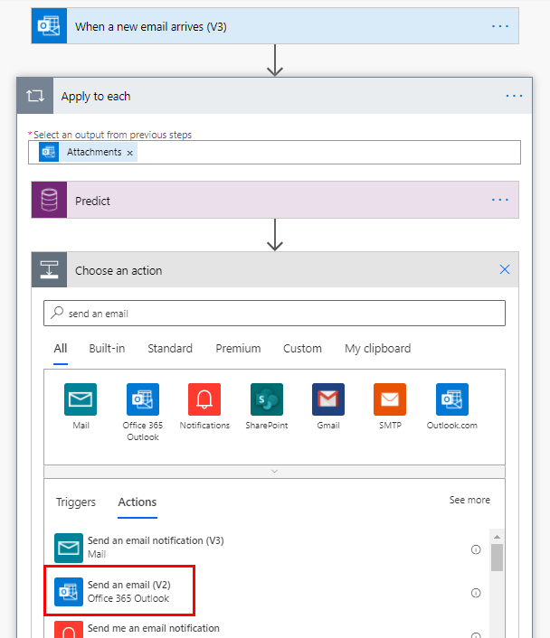

1. On the To field click on “Add dynamic content” and search for “From” . This will the email address of the sender party.

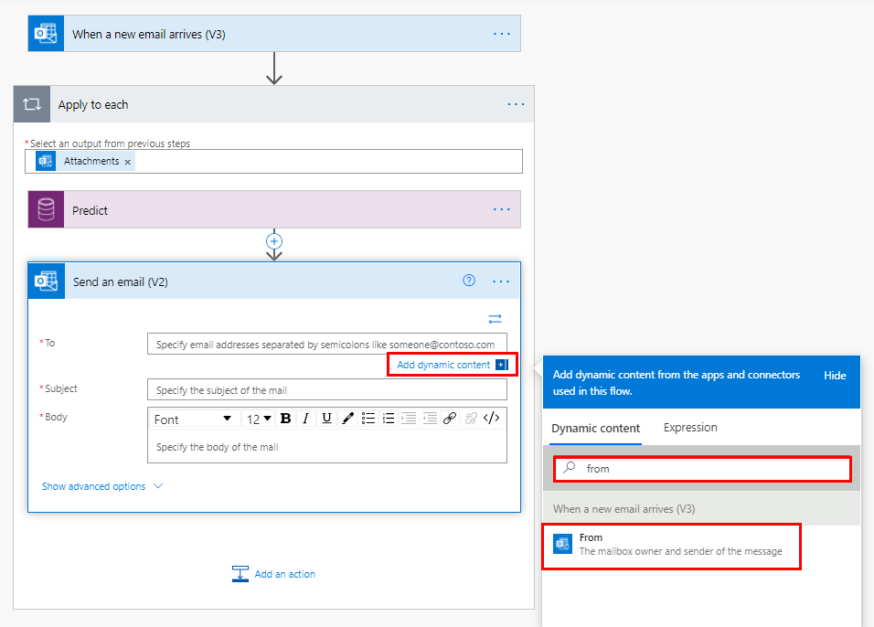

1. Fill up the rest of the fields for the email step:

* Subject: “Thanks for sending the invoice”
* Body: “We received an invoice with those information” and “We will process and get back to your shortly” and together with the following variables values from Dynamics variables panel under AI Builder action

1. Click Save.

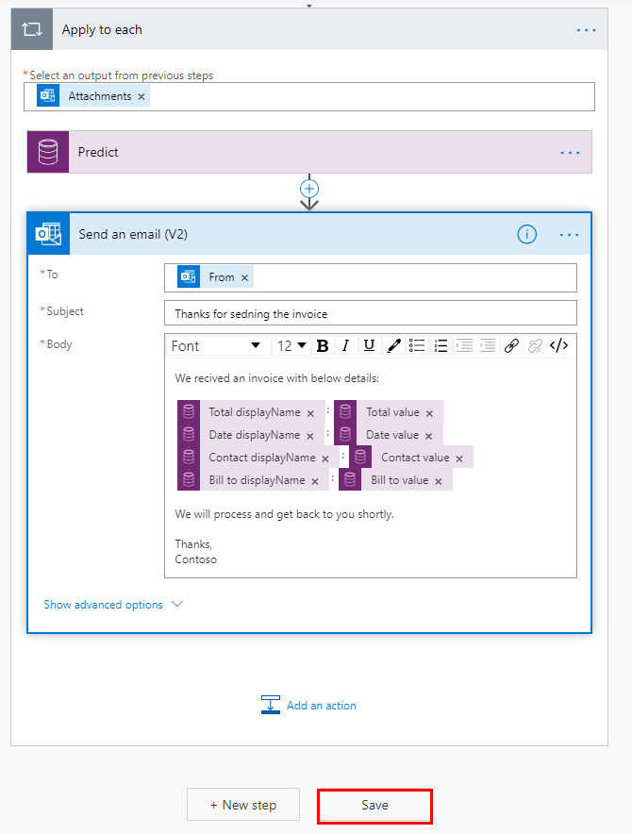

1. Click **back** button before the flow name to the flow detail page

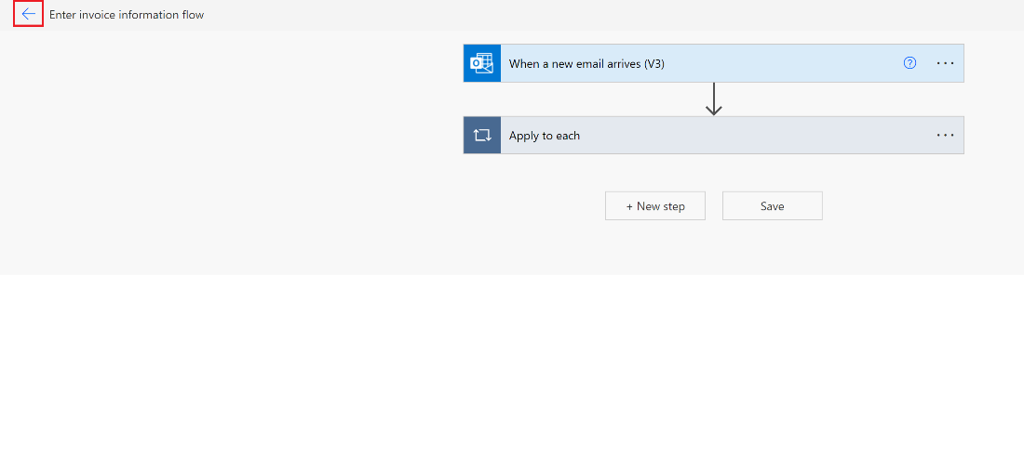

1. Trigger the flow to test by sending an email. In a separate tab, open the Office 365 Outlook app.
2. Compose a new email with the following settings:
   1. To: *{email address of the user identity you are using in this lab}*
   2. Subject: **New invoice**
   3. Attachments: **newinvoice.jpg** *(from the lab resource files)*

**Note**: This attachment can be in any of the jpg or pdf format and AI builder model can process both. Here we just use jpg file in this exercise.

**Note**: Your email signature may be viewed as an attachment. That will block this flow logic unless we add more validation. So, we recommend you try to send email without signature.

1. Send the email and now the flow should be triggered to run automatically.
2. Now go back the flow detail page in the original tab. Notice a new run has been kicked off. Note, you might have to click refresh button a few times to see the new run history.

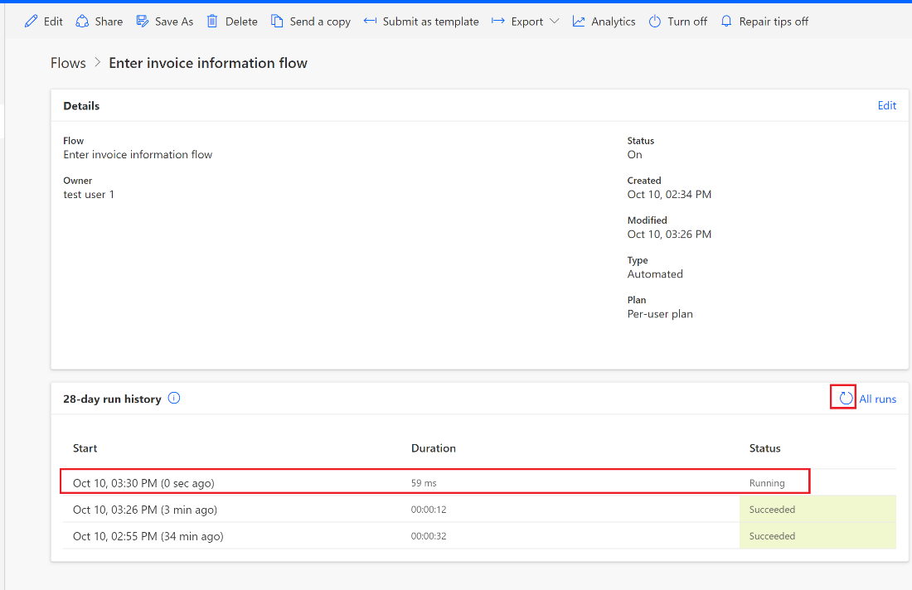

1. Click to open this run details. It will show whether your flow ran successfully.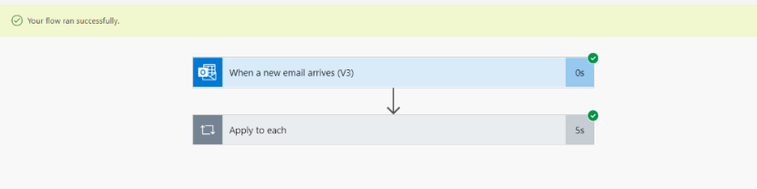
2. You can also click the title to expand the Apply to each action and AI Builder action to view the output from the Predict action. It should contain the data parsed from the file. That output will be able to be consumed by the following actions. We will cover that in next lab #7.

1. You should now also have received an acknowledgment email with the AI Builder process results against the jpg invoice file.

Check your knowledge

Lab 6

7 mins

1. After uploading our sample documents in AI Builder, we can click the _______ button to teach the model to process our future documents.
2. Analyze
3. Train
4. New collection
5. None of the above

Answer: B. Train

1. How do we tag our document?
2. Hover over the respective area and then click on that area
3. Hold down CTRL and click on that area
4. Hold down ALT and click on that area
5. Hold down Shift and click on that area

Answer: A. Hover over the respective area and then click on that area

1. Do we need to ensure that our fields have been recognized on all our documents by clicking them one by one and ensuring we have green checkmarks beside our fields?
2. True
3. False

Answer: A. True, fields need to be recognized across all documents for the document to be trained properly.

Information in this document, including URL and other Internet Web site references,  
is subject to change without notice. Unless otherwise noted, the example companies, organizations, products, domain names, e-mail addresses, logos, people, places, and events depicted herein are fictitious, and no association with any real company, organization, product, domain name, e-mail address, logo, person, place or event is intended or should be inferred. Complying with all applicable copyright laws is the responsibility of the user. Without limiting the rights under copyright, no part of this document may be reproduced, stored in or introduced into a retrieval system, or transmitted in any form or by any means (electronic, mechanical, photocopying, recording, or otherwise), or for any purpose, without the express written permission of Microsoft Corporation.

Microsoft may have patents, patent applications, trademarks, copyrights, or other intellectual property rights covering subject matter in this document. Except as expressly provided in any written license agreement from Microsoft, the furnishing of this document does not give you any license to these patents, trademarks, copyrights, or other intellectual property.

The names of manufacturers, products, or URLs are provided for informational purposes only and Microsoft makes no representations or warranties, either expressed, implied, or statutory, regarding these manufacturers or the use of the products with any Microsoft technologies.  
The inclusion of a manufacturer or product does not imply endorsement of Microsoft of the manufacturer or product. Links may be provided to third party sites. Such sites are not under the control of Microsoft and Microsoft is not responsible for the contents of any linked site or any link contained in a linked site, or any changes or updates to such sites. Microsoft is not responsible for webcasting or any other form of transmission received from any linked site. Microsoft is providing these links to you only as a convenience, and the inclusion of any link does not imply endorsement of Microsoft of the site or the products contained therein.

© 2021 Microsoft Corporation. All rights reserved.

Microsoft and the trademarks listed at https://www.microsoft.com/enus/legal/intellectualproperty/Trademarks/Usage/General.aspx  
are trademarks of the Microsoft group of companies. All other trademarks are property of their respective owners.